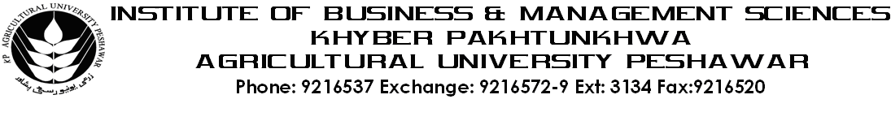
Programme: BS (IT)-III
Course Name: Information Systems
Course Code: IT-402
Credit Hours: 03
Course Week: 16

Total Hours: 48

Course Objectives
The objective of this course is to prepare students to be part of teams that imagine, specify, design, justify, build, implement, manage and use information systems. To accomplish this objective, graduates must understand how to use information technology, including hardware, software, and telecommunications, as a conduit for the value-added information content of formal organisational systems. This understanding is based on a solid theoretical grounding in both technology and organisations, as well as on experience working both individually and in teams to apply the theory to practice.

Week-1
-Introduction to Information System
- What is an Information System?
- Information Society Evolution: Periods of Change
- Typical Careers (Executive Roles) in Information Systems
- IS Role in Change: Trends and Terms
- The Future of Information Systems: Trends

Week-2
- System theory and Concepts
- What is a System?
- Levels of System
- Types of Systems
- System components and relationships
Week-3
- Information Systems Components
- Data
- Hardware
- Software
- Telecommunications

- The factor affecting the value of information in organization
- Completeness
- Accuracy
- Correctness
- Timeliness etc

Week-4
- The Information Processing Cycle
- Acquisition, input, validation, processing, storage, retrieval, output, communication and disposal
- How information systems can help achieve organizational goals

Week-5
- Types of information system
- Transaction processing system and its types
- Office automation system (OAS) and its types
- Management information system (MIS)
- Executive information system (EIS)
- Decision support system (DSS)
Week-6
- Understanding Ethics Related To Information Systems
- Information Systems Ethics
- Information Privacy, Accuracy, Property and Accessibility
- The Need of Ethical Behavior
- Computer Crimes and the Impact on Organizations
Week-7
- Introduction to Decision Making related to Information Systems
- Levels of Decision Making
- Types of Decision Making
- Stages of Decision Making
- What Managers Do (The Technical-Rational Perspective and Behavioral Perspective)
Week-8
- Information Systems for Competitive Advantage
- Three Primary Uses of Information Systems
- Information Systems Roles in the Value Chain
- Making a Business Case
- Business Case Development Issues
- Assessing Value for IT Infrastructure
Week-9
- Information Systems Software and Hardware
  - Introduction to System Softwares and its types
  - Introduction to System Hardware and its types
Week-10
- Developing Information Systems (IS)
  - Information Systems Development Overview
  - The Systems Development Life Cycle
  - System Identification, Selection, and Planning
  - Systems Analysis
  - System Design
  - System Implementation
  - System Maintenance
Week-11
- Approaches to Information Systems (IS) Building
  - The Traditional Systems Lifecycle
  - Alternative System-Building Approaches (Prototyping, Application Software Packages & End-User Development)
  - System-Building Methodologies and Tools (Structured Methodologies, Object Oriented Software Development, CASE & RAD)
Week-12
- Information Systems (IS) Success and Failure
  - IS Failure and Measuring IS Success
  - Causes of IS Success and Failure
  - Ensuring System Quality
Week-13
- Information Systems (IS) Security and Control
  - Introduction to Information Security
  - IS Vulnerability and Abuse
  - Creating Computer Operations controls, Data Security controls, Administrative controls and Application controls
Week- 14
- Data and Knowledge Management
  - Importantance of Databases to Modern organizations?
  - Overview of Databases and DBMS
  - Knowledge Management System (KMS)
  - Benefits and Challenges of KMS
Week-15
- Human-computer interface
  - Graphical User Interface
  - Problems with old conventions
  - Need for GUI environment
  - CLI versus GUI
Week-16
- Telecommunications and Networks
  - The Telecommunications Revolution
  - Telecommunications System Components
  - Communications Networks and Standards

Total Marks: 100

Recommended Books:

1. Information systems Today 2nd edition by Leonard Jessup
2. Management Information Systems: Organization and Technology, 6th edition, by Kenneth C. Laudon
3.

